**easyenglish**

Learn English and prepare IELTS with us!

<https://easyenglishgroup.000webhostapp.com>

https://github.com/u1610021/EasyEnglishProject

**Team members:**

Yunus Utepbergenov u1610253

Alibek Begnaev u1610019

Alisher Karimov u1610021

Tolib Rakhmonov u1610243

Description

EasyEnglish is the free blog which can teach you English and prepare for IELTS test online to get higher scores. We create special tactics to learn English quick and ideal. This website contains highly rated tips, video lessons, and examples for IELTS preparation. These materials token from experienced IELTS experts all over the world.

This website is created as easy as possible to access and search the materials. Using this blog you are able to learn English or improve it, and prepare for IELTS and get higher scores. It is completely free and out of unnecessary ads. There are no limits of age and knowledge. Start achieve your goals with us.

Our website contains from five main parts: admin panel, IELTS part, Grammar part, homepage and books.

In admin panel only admin can sign in and is able to change or add blogs. Admin can also control the comments in each section.

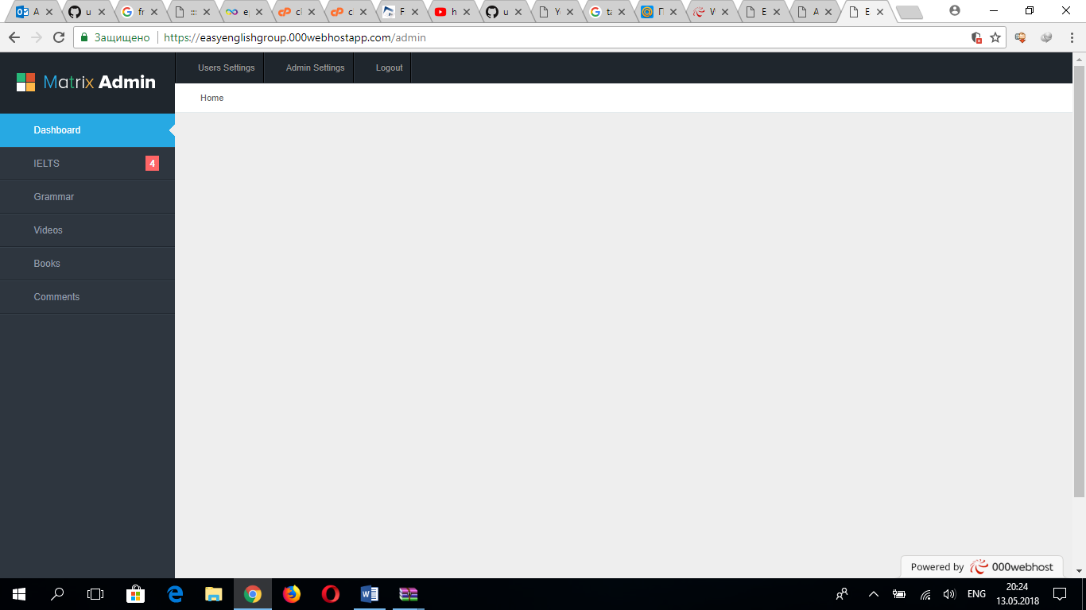

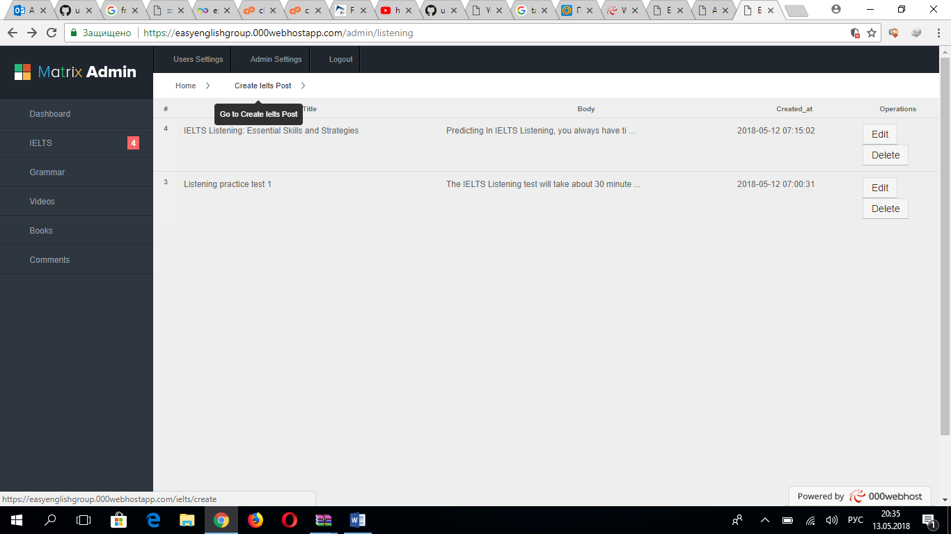

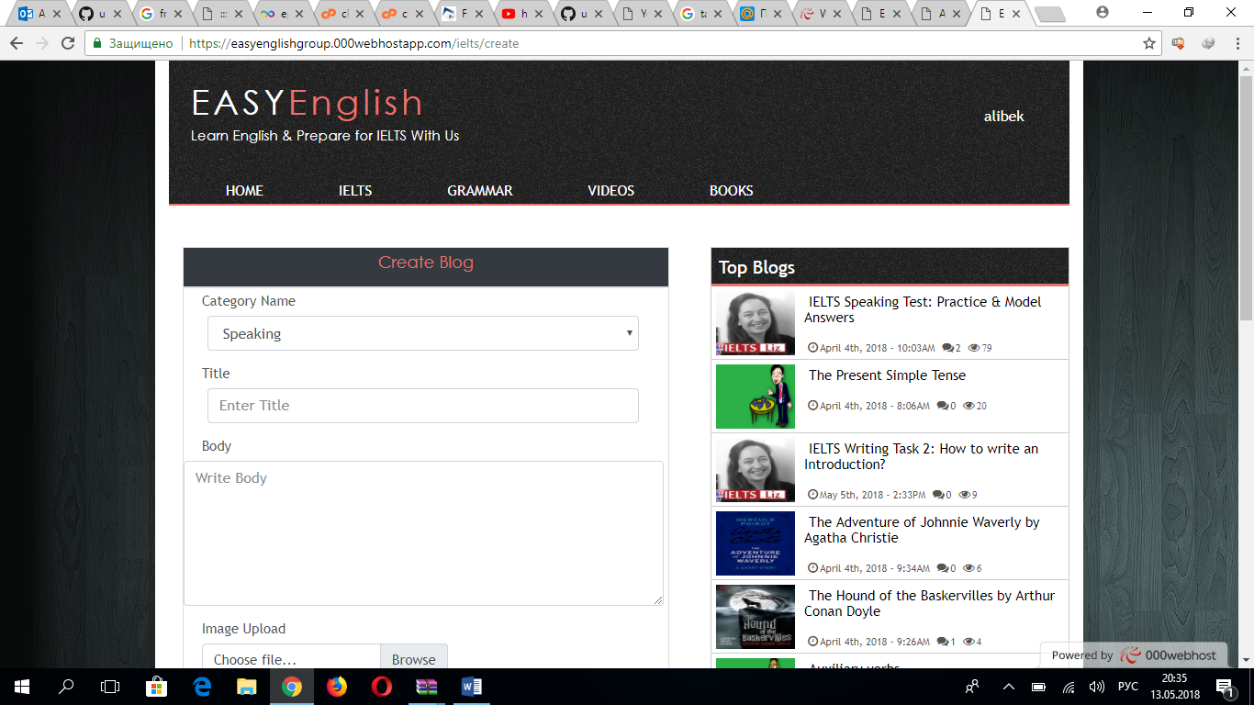

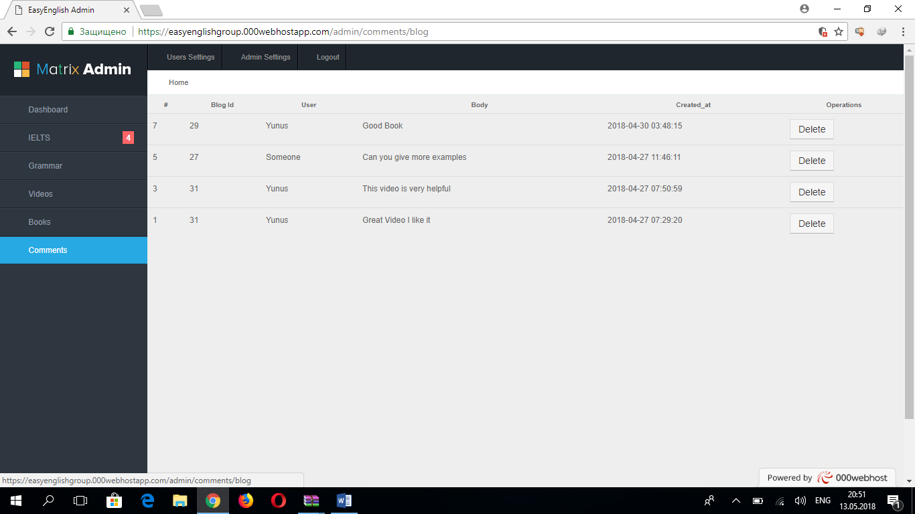

IELTS part is divided into 4 sections: Listening, Reading, Writing and Speaking. There are interesting and useful video lessons, examples and articles which helps you to prepare for IELTS test in the each section.

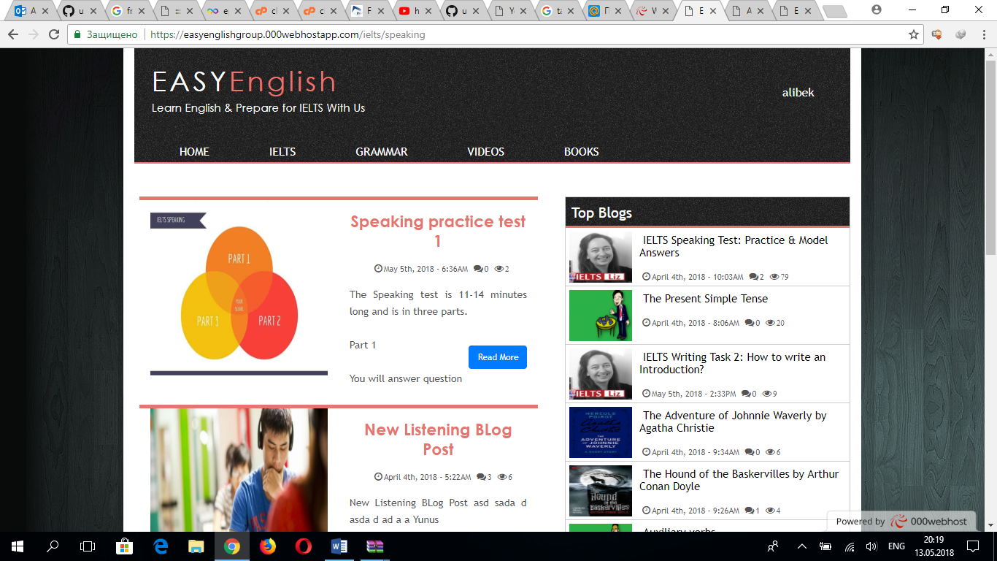

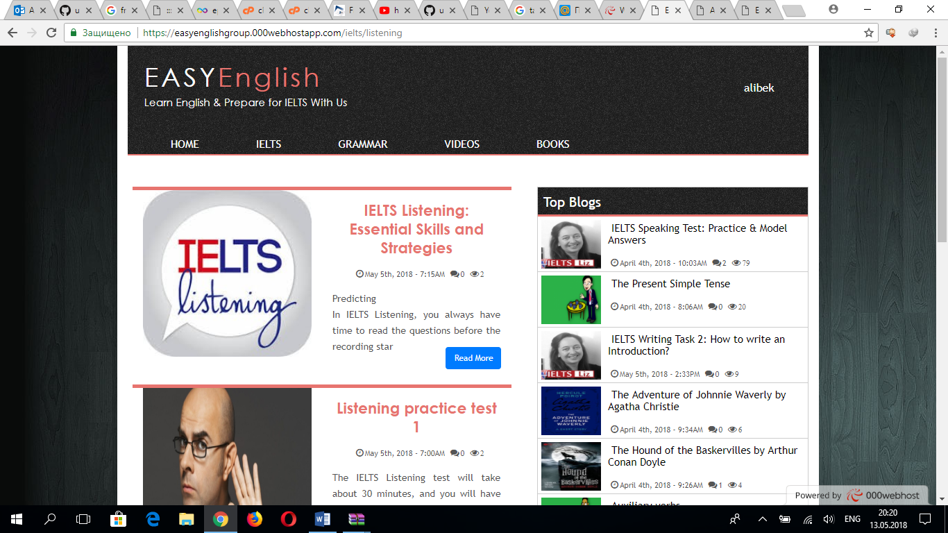

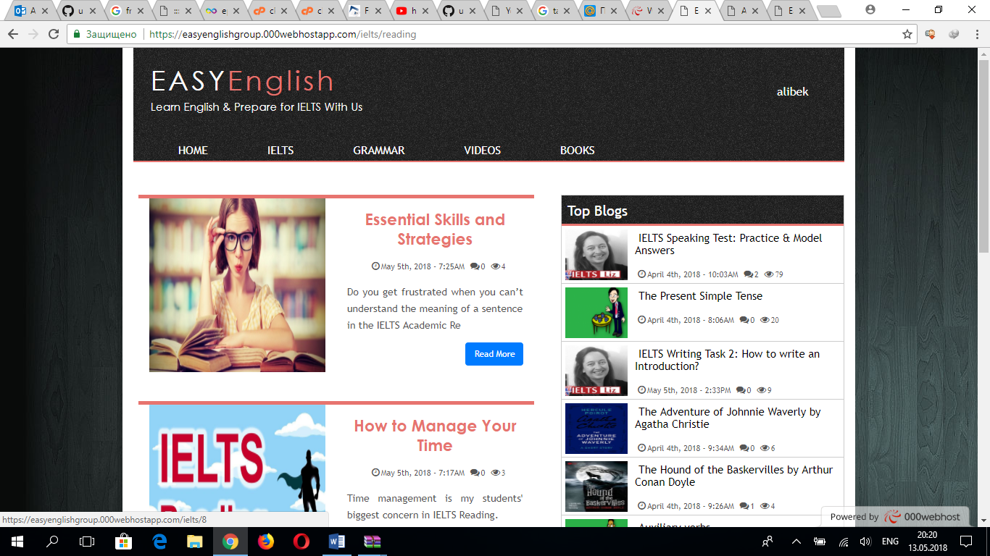

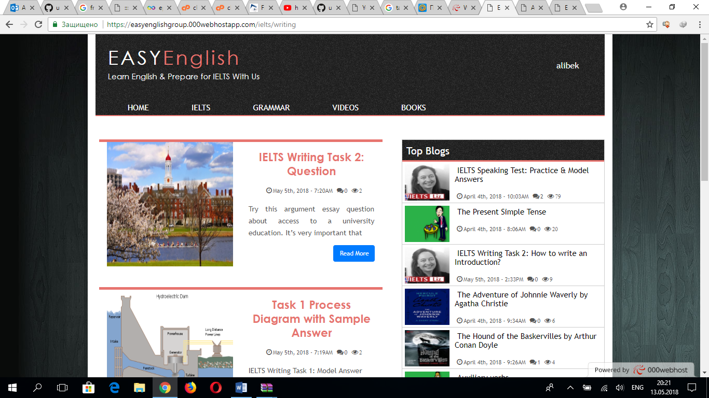

Grammar part contains articles and examples about grammar rules.

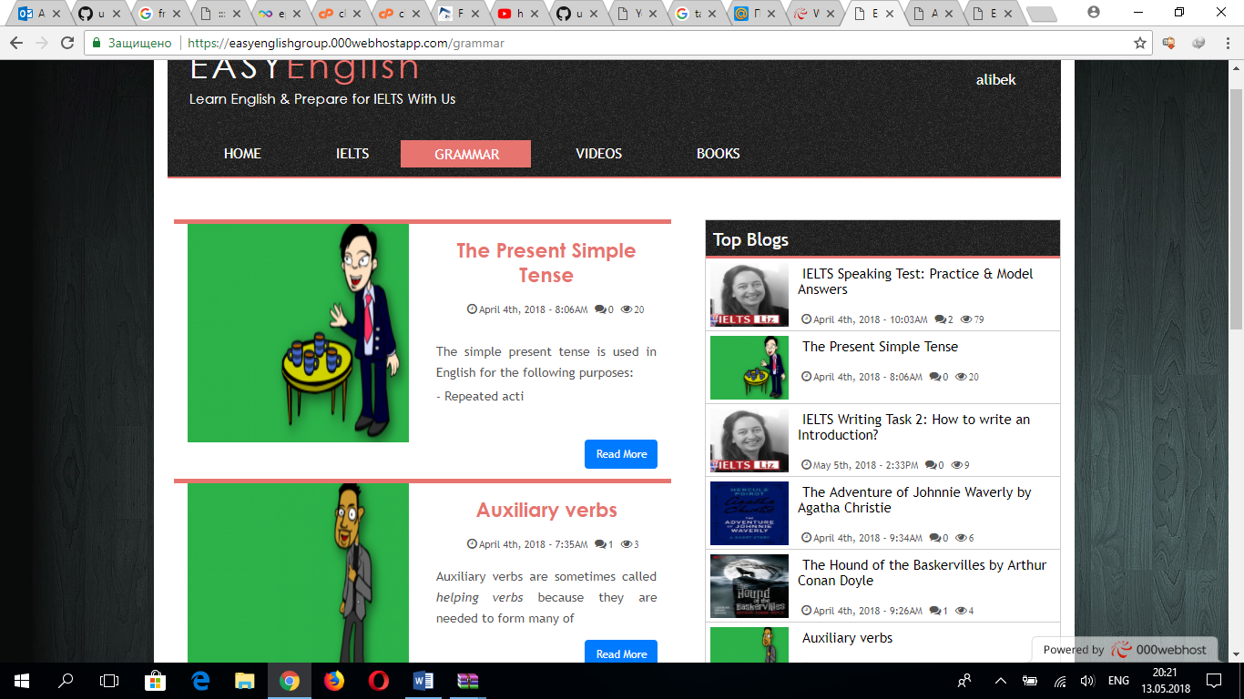

In the Homepage, there are latest news about IELTS and English language sphere, and opinions and advertisements to get higher scores on IELTS and to learn English quickly by experienced teachers as well as people who got higher results on IELTS test.



There is Book section too which contains some interesting and famous books and novels. They will help users to improve their reading skills and vocabulary.

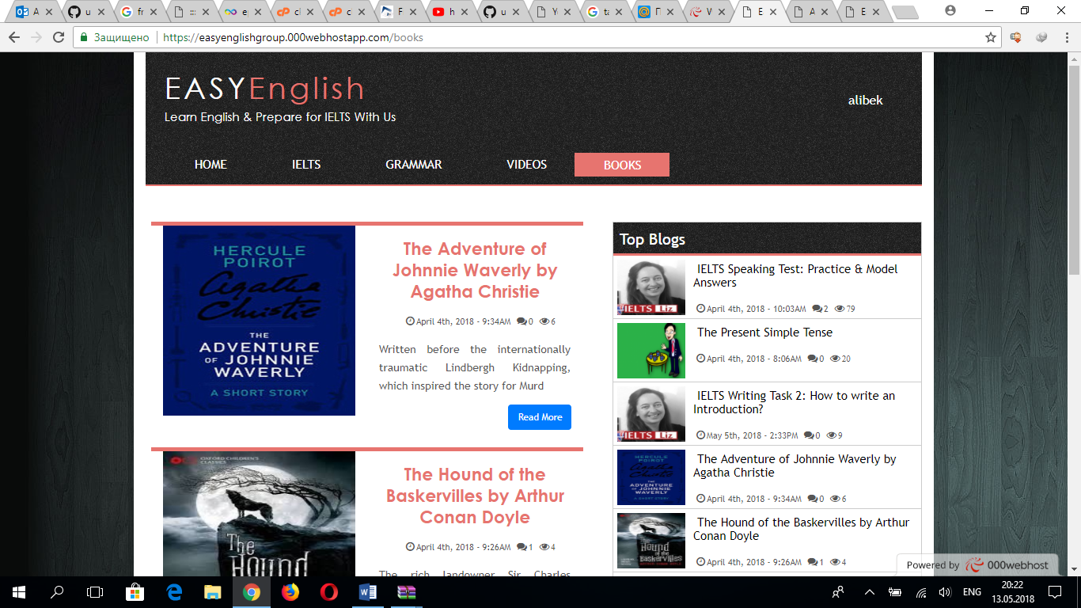

There are other parts too in website:

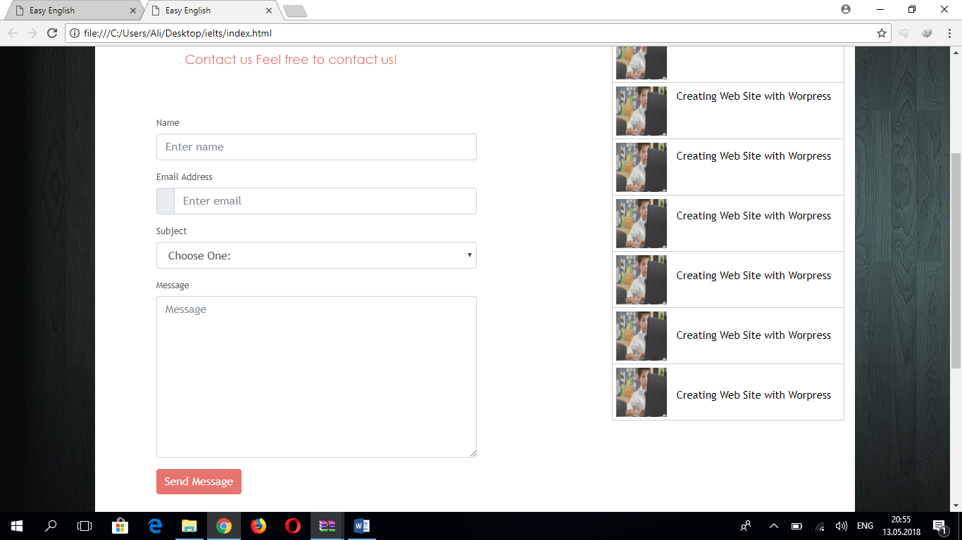

Our team consist of 4 members. Every member has their own role in the group and each member helped to each other.

Tolib Rakhmonov: HTML, CSS, did good designs for site.

Alisher Karimov: HTML, CSS, admin panel.

Alibek Begnaev: Bootstrap, JavaScript.

Yunus Utepbergenov: Laravel, PHP and database.